Project Instructor

Sir, Talha Qureshi

(Submitted By)

Syeda Kaneez Batool Rizvi

Hasnain Kabeer

Shaaz Siddiqi

Muhammad Bilal Bilal

|  |  |
| --- | --- |
| **Fusion Fiesta** | **2025**  **Aptech Learning Center** |

**TECH WIZ**

Table of Contents

Project Certification2

Welcome to Fusion Fiesta3

Problem Statement4

Requirement Summary5

Task Sheet6

Site Map7

List of validation 8

Task Sheet9

Submission Checklist10

Project Certification

This is to certify that,

Mr. Miss,

Syeda Kaneez Batool Rizvi (1649228)

Hasnain Kabeer (1654510)

Shaaz Siddiqi (1644923)

Muhammad Bilal Bilal (15952242)

Has successfully Designed & Develop

**Fusion fiesta**

Submitted by: (Syeda Kaneez Batool Rizvi, HasnainKabeer, Shaaz Siddiqi and Muhammad Bilal Bilal)

Welcome to Fusion Fiesta

**Problem Statement:**

During the development of the Fusion Fiesta website, several challenges were faced. These included difficulties in designing a user-friendly interface, ensuring responsive layouts for different devices, managing multiple brand data, and integrating a proper comparison system. Limited time and resources also created hurdles in completing the website efficiently.

**Problem Areas:**

• designing a simple and user-friendly interface.

• Making the website responsive across devices.

• Managing and organizing event-related data.

• Adding and maintaining multiple brands.

• Implementing a brand comparison feature.

• Ensuring smooth navigation between pages.

• Time and resource limitations during development.

Requirement Specification

The app should be designed as a set of Forms/Pages, Navigation, and

Fragments/Screens with menus representing choice of activities to be

performed.

Following are the functional requirements of the cross-platform app:

1. User Registration and Authentication:

The Fusion Fiesta app should support a robust user registration and

authentication system that accommodates different types of users:

General visitors (students who only browse)

Participants (students who register for events)

Staff members (who act as organizers or administrators)

❖ The registration process should allow users to select their role

during sign-up: Student Visitor, Student Participant, or Staff

(Organizer/Admin).

❖ A normal student can browse event listings and view gallery

content, but cannot register for events without upgrading their role

to Participant.

❖ A student participant should provide additional details such as

enrolment number, department, and college ID proof. The college

credentials cannot be verified, however, as that is beyond the

scope of the project. This enables students to register for events

and download participation certificates upon payment of

certificate fees.

Media Gallery:

❖ The app should feature a categorized event gallery where users can

browse photos and videos from past college events.

❖ Organizers should be able to upload high-quality images and short

video clips related to their events after completion.

❖ Media files can be tagged with event names, dates, categories (for

example, cultural or technical) and departments for easy filtering.

❖ Students and visitors can browse the gallery, filter by event type or

date, and save favorite images/videos to their profile.

❖ Admins should be able to moderate uploaded media, remove

inappropriate content, and highlight select gallery items on the home

page.

❖ The gallery section should be visually appealing, lightweight, and

responsive, with options to preview, expand, or share content (if enable)

Feedback and Ratings System:

❖ After attending an event, students should be prompted to provide

feedback, which may include a star rating (1 to 5) and an optional text

comment.

❖ The feedback form should ask students to rate the event on

parameters such as organization, relevance, coordination, and

overall experience.

❖ Submitted feedback should be visible to the organizers, who can use

it to assess and improve future events.

❖ Admins should have access to summarized feedback reports,

including average ratings, most-used keywords, and suggestions by

category.

❖ A feedback moderation system should be implemented to flag and

review inappropriate language or spam.

❖ Events with higher feedback scores may be marked as ‘Top Rated’ and

promoted within the app.

About Us and Contact Us Pages:

❖ The app should include an About Us page that explains the purpose of

the app, the team behind it, and the benefits for students and staff.

❖ The Contact Us section should provide a contact form where users

can submit queries, technical issues, or general feedback.

❖ This form should collect the user’s name, email, subject, and

message, and send it to the admin email or database for follow-up.

❖ A Google Maps integration should allow users to view the physical

location of the institution, with optional GPS navigation if enabled.

❖ Frequently Asked Questions (FAQs) may also be added to help users

with common issues or app usage guidance.

Hardware/Software Requirements

Hardware:

* A minimum computer system that will help you access all the tools in the

Courses is a Pentium 166 or better.

* 64 Megabytes of RAM or better.

Software:

• Notepad/HTML editor/Coffee Cup

• Angular / Angular JS / React / Bootstrap

• Dreamweaver / Figma

• MS IE / Chrome / Firefox / Netscape /MS Edge

Project Duration

1. Analysis -15 Hrs.
2. Design -20Hrs.
3. Development -20 Hrs.
4. Testing -10 Hrs.
5. Documentation -9Hrs.

Task Sheet

|  |  |  |  |
| --- | --- | --- | --- |
| No | Task | Team Mate Name | Status |
| 1 | Case study | Syeda Kaneez Batool Rizvi  Hasnain Kabeer  Muhammad Bilal Bilal  Shaaz Siddiqi | Completed |
| 2 | Graphic designing | Syeda Kaneez Batool Rizvi  Hasnain Kabeer  Muhammad Bilal Bilal  Shaaz Siddiqi | Completed |
| 3 | Site interface  designing | Syeda Kaneez Batool Rizvi  Hasnain Kabeer  Shaaz Siddiqi  Muhammad Bilal Bilal | Completed |
| 4 | Material Searching | Syeda Kaneez Batool Rizvi  Hasnain Kabeer  Shaaz Siddiqi  Muhammad Bilal Bilal | Completed |
| 5 | Site  Testing/publishing | Syeda Kaneez Batool Rizvi  Hasnain Kabeer  Muhammad Bilal Bilal  Shaaz Siddiqi | Completed |
| 6 | Documentation | Syeda Kaneez Batool Rizvi  Hasnain Kabeer  Muhammad Bilal Bilal  Shaaz Siddiqi | Completed |

Site Map

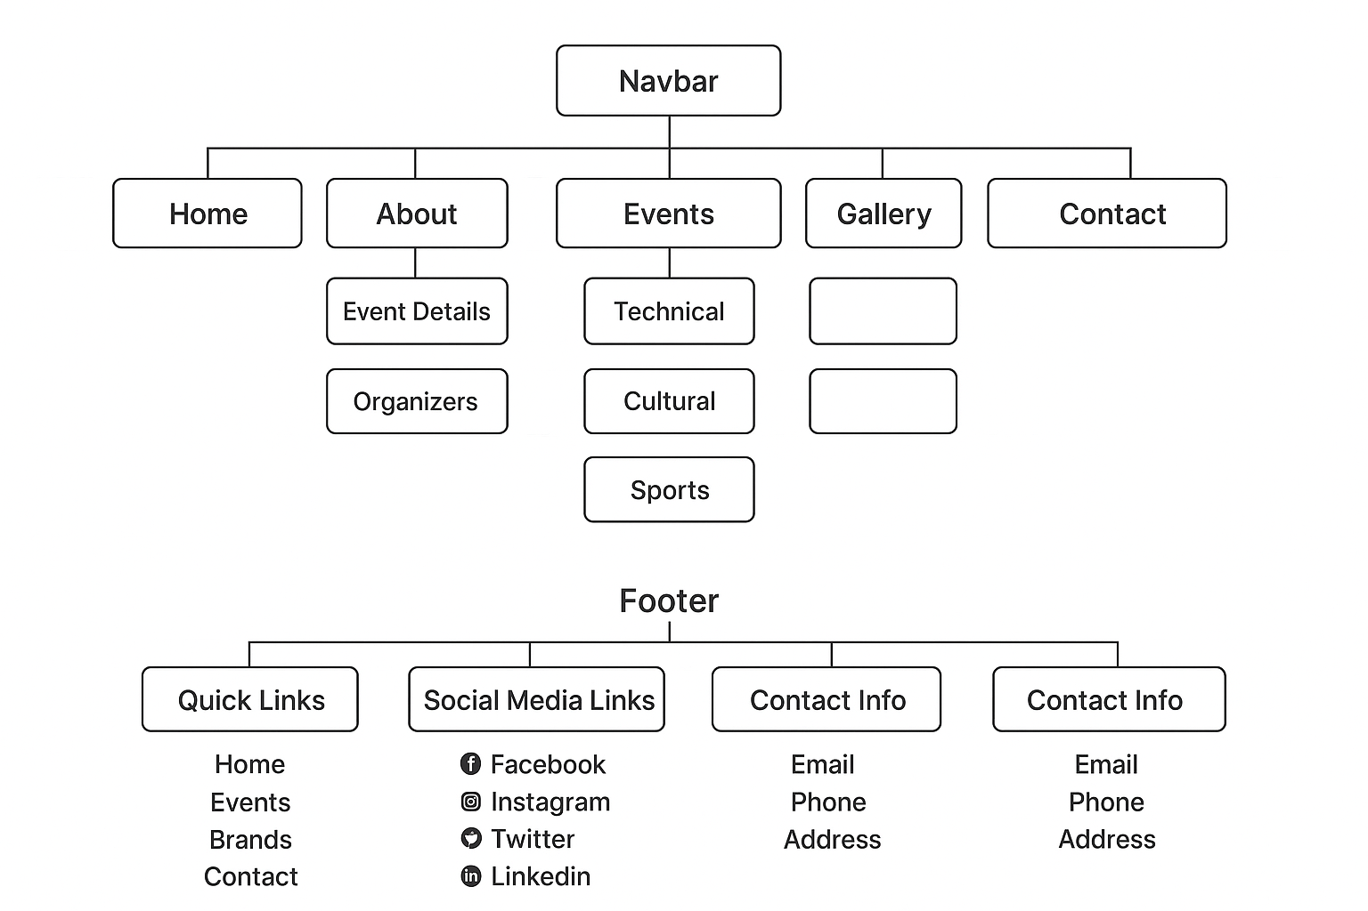

List Of Validation

|  |  |
| --- | --- |
| Option | Validation |
| Field in form should not be Null | Yes |
| Hyperlink Have Alternating Text | No |
| Search pages | Yes |
| Homepage Has Forward Only Link | Yes |
| All Web pages have link back Homepage | Yes |
| Request Quote from included | Yes |
| All Functions Are Compatible with Firefox | Yes |
| All Functions are Compatible with IE | No |

Submission Checklist

|  |  |  |  |
| --- | --- | --- | --- |
| S.No | List Of Items | Remarks | Comments |
| 1 | Do all pages linked together | Yes |  |
| 2 | All Hyperlink working | Yes |  |
| 3 | Page color as per common guideline | Yes |  |
| 4 | Site Browser compatible | No | Tested in only Firefox |
| 5 | Image slicing | Yes | Using AdobePhotoshop,AdobeFlash |
| 6 | Feedback from included | Yes |  |
| 7 | Project Zip file | Yes | Created using Win RAR |

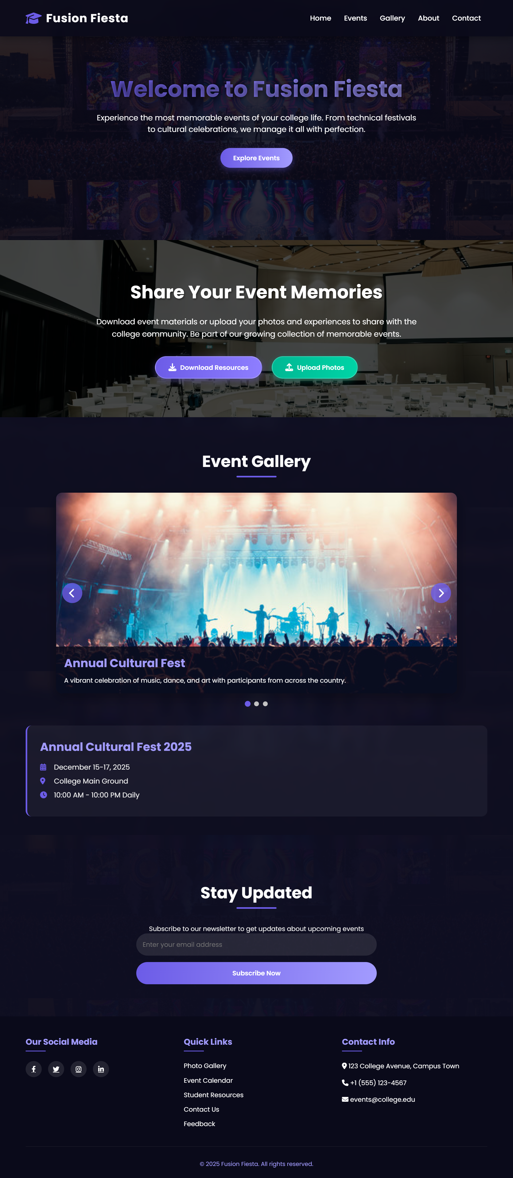

Home Page

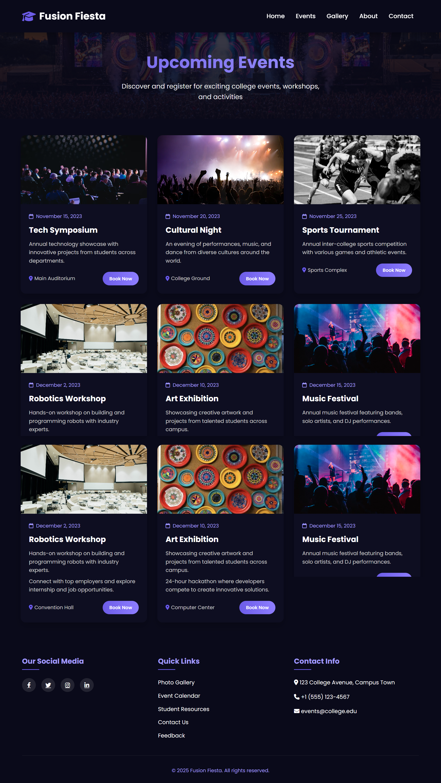

Event Page

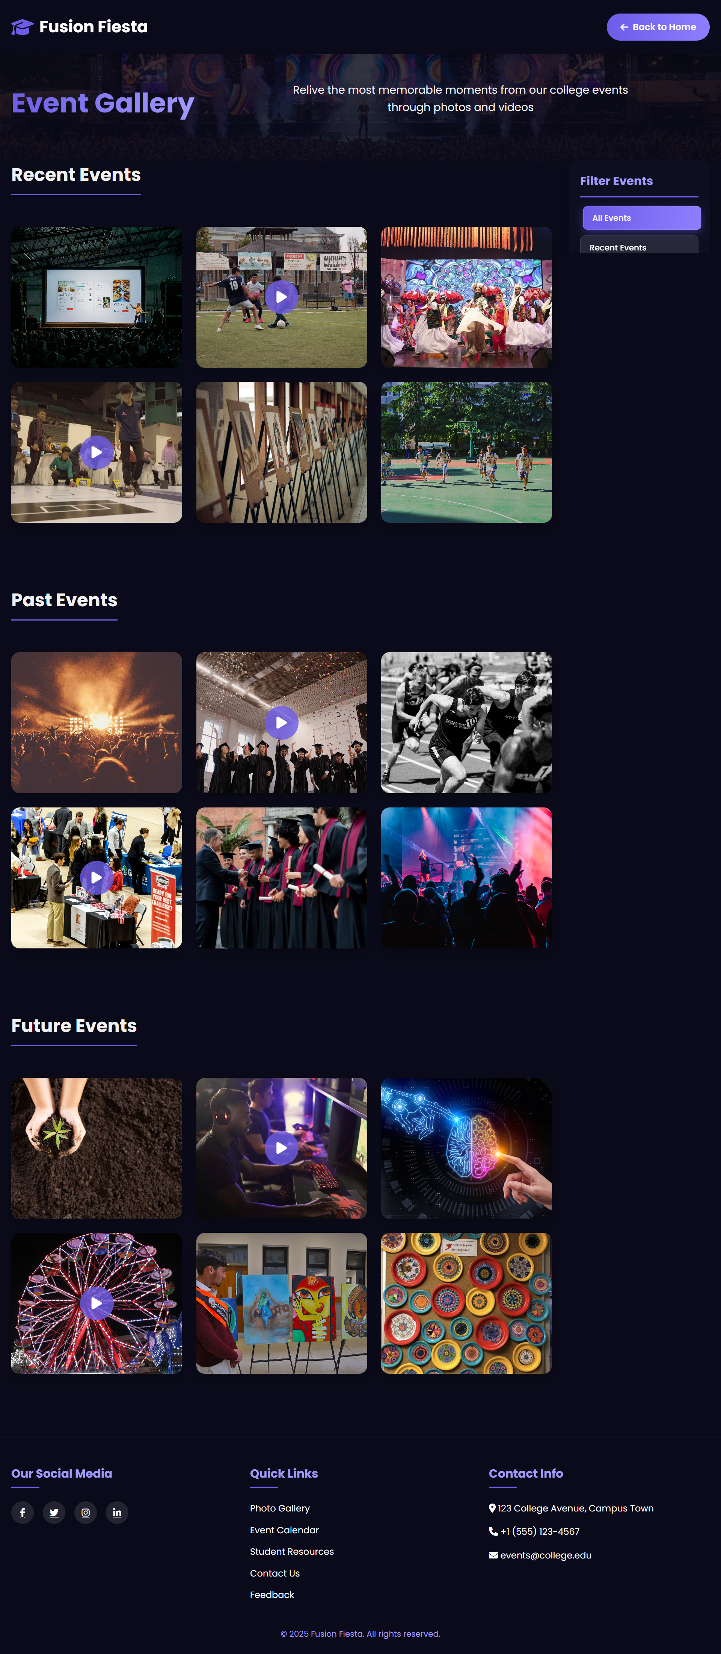

Gallery Page

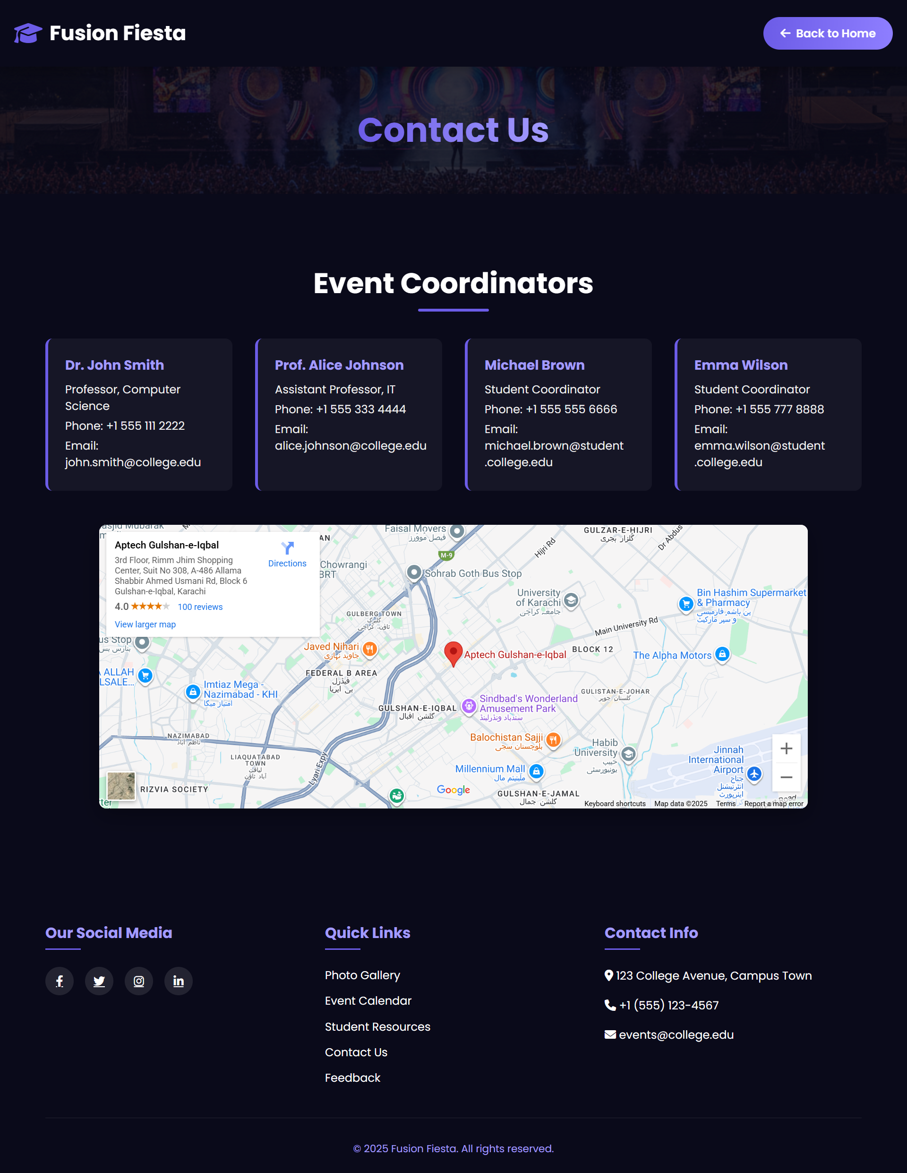

Contact Page

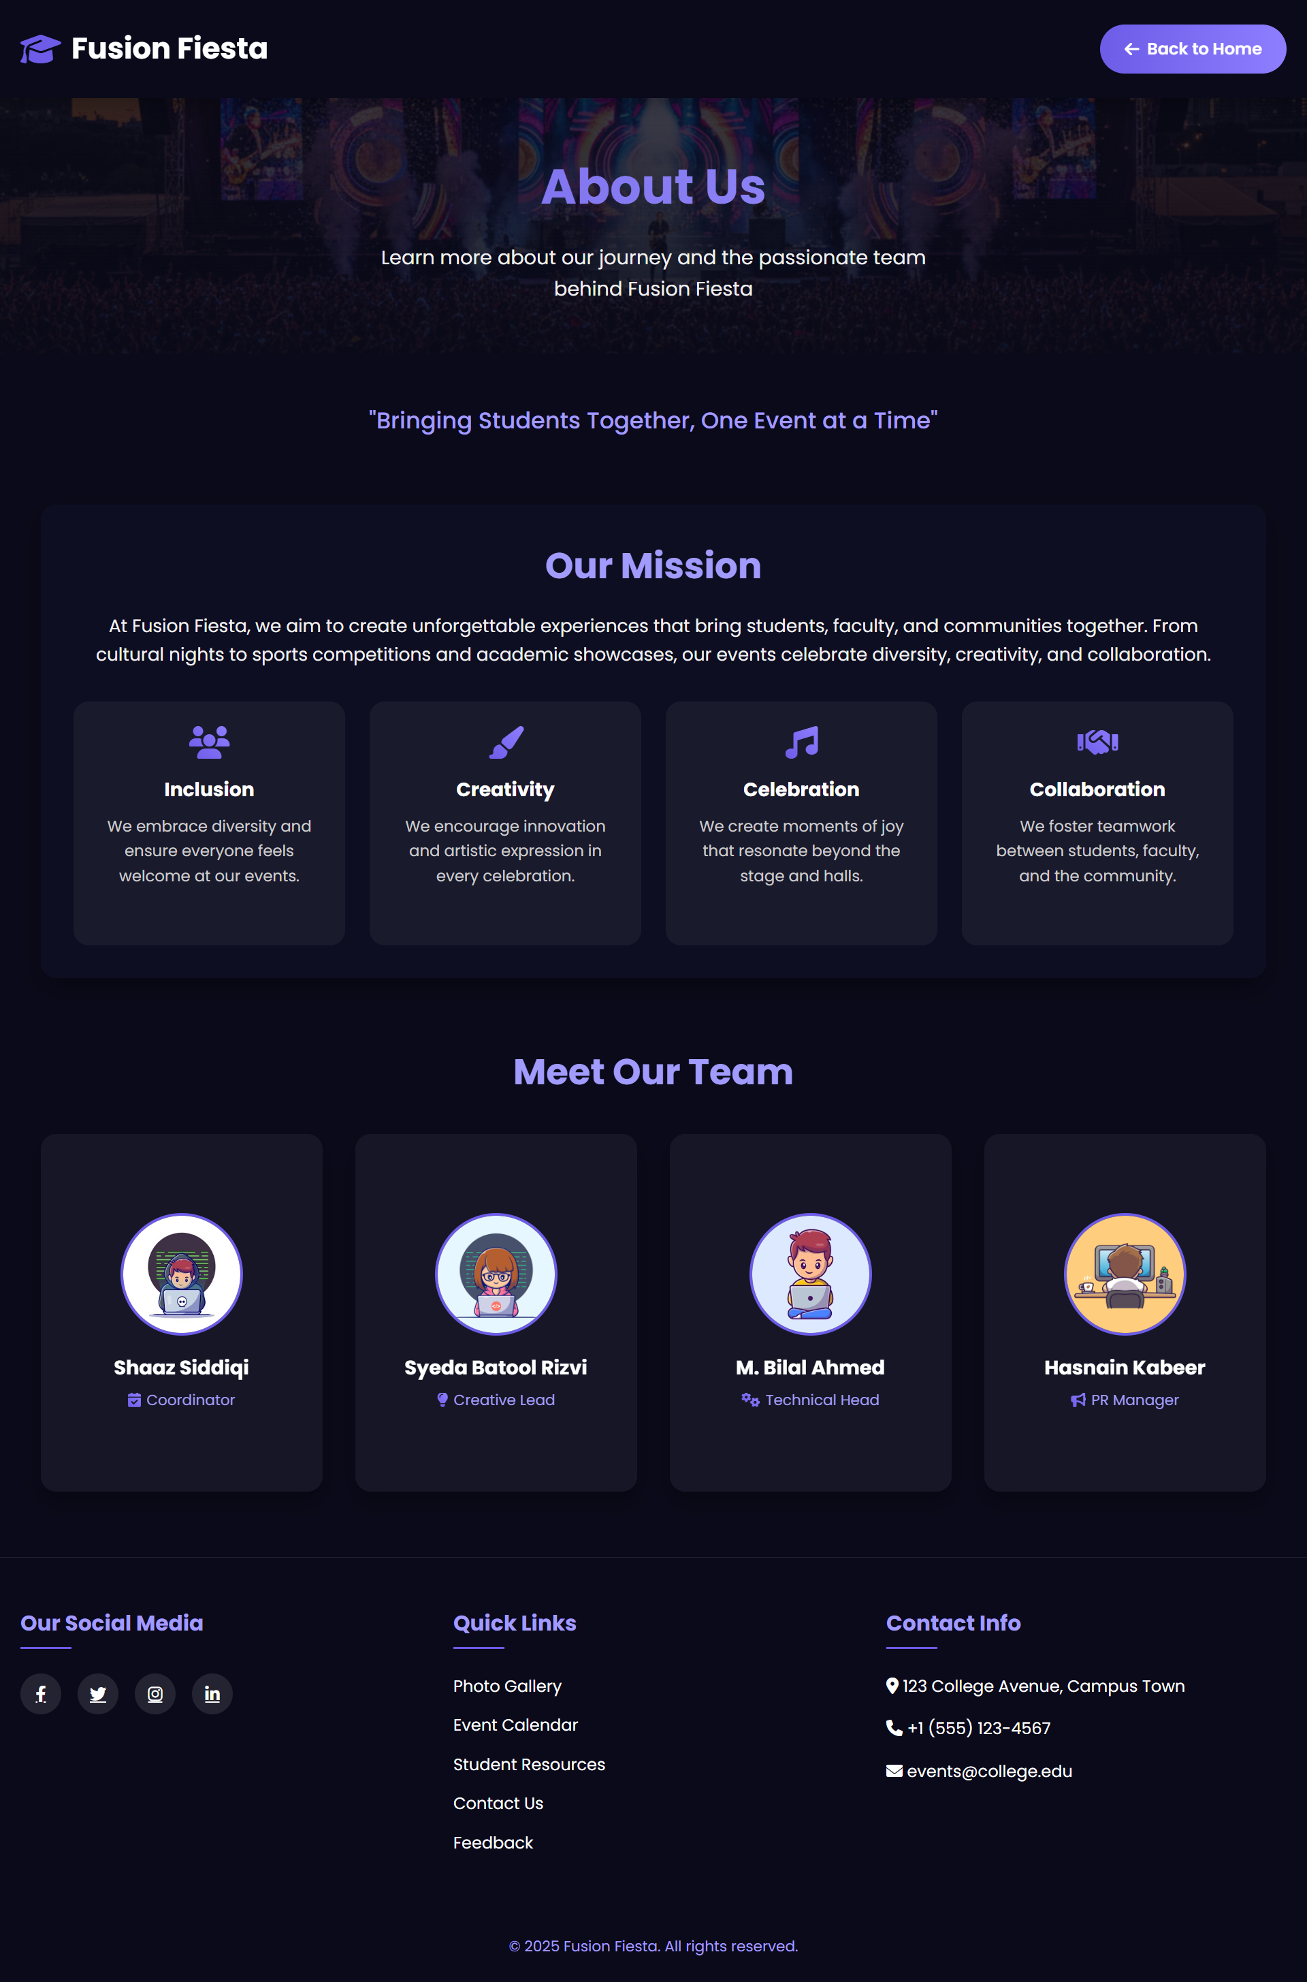

About Page

Calendar Page

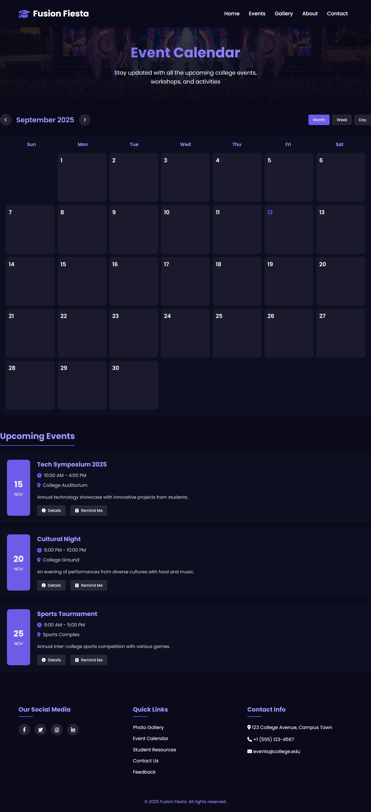

Ethic Page

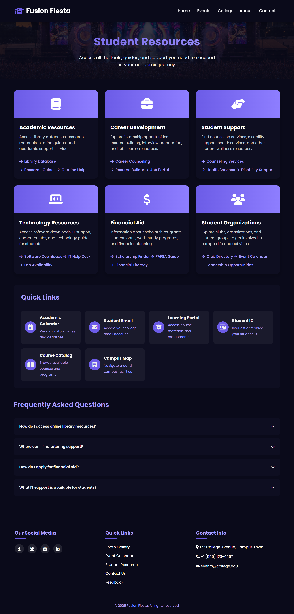

Resources Page

Feedback Page

